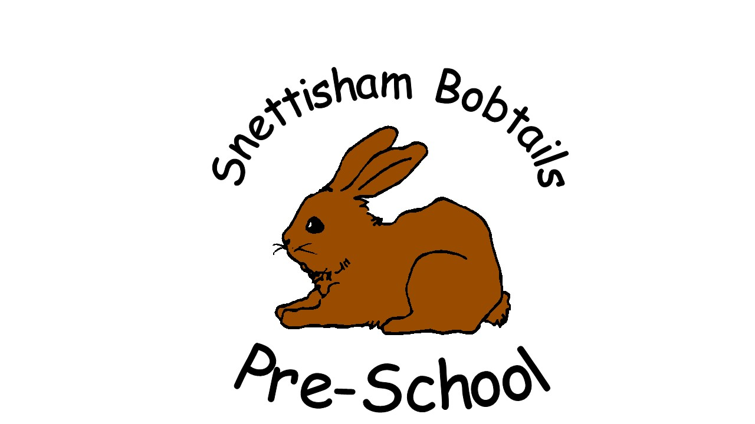
Snettisham Bobtails Pre-School Terms and Conditions

Terms and conditions

  - Our obligation to you
  - We will inform you as soon as possible whether your application for a place has been successful. You must confirm within one week of receiving notification that you still wish to take up a place. If you do not then the offer of a place may be withdrawn. Once you have confirmed the place.
  - We will provide the agreed childcare facilities for your child at the agreed times (subject to any days when we are closed). If we change the opening hours, we will give you as much notice of our decision as possible and, if necessary, will work with you to agree a change to your child’s hours of attendance.
  - We will try to accommodate any requests you may make for additional sessions and/or extended hours of childcare.
  - We will notify you as soon as possible of any days we will be closed.
  - We will treat your child with the utmost respect and dignity. We will never use or threaten any type of punishment that could adversely affect a child’s wellbeing.
  - We will provide you with regular verbal updates as to your child’s progress and we will agree times to discuss with you the progress of your child or any other aspects of our childcare services as and when required.
  - We will comply with the requirements of the Early Years Foundation Stage and our Ofsted registration in regard to the childcare services we provide for your child.
  - We will provide you with details of our policies and procedures, which outline how we satisfy the requirements of the EYFS in our everyday practice; and we will notify you as and when any changes are made to our policies and procedures. We will be available to discuss or explain our policies and procedures, and/or any relevant changes, at a mutually agreed time.
  - We will maintain appropriate insurance to cover our childcare activities.
  - We will try to make a place available to any of your other children. However, we cannot guarantee that a place will be available.

- Your obligation to us
- You will need to complete and return our Registration Form to us before your child can start with us.
- You must notify us immediately of any changes to the information you have provided to us and keep us informed of any other necessary information that may affect the childcare that we provide for your child.
- The Registration Form includes medicine consent and emergency treatment authorisations which you will need to complete prior to your child attending.
- You will read and abide by our policies and procedures.
- You will make yourself available as and when required to discuss the progress of your child or any factor relating to their childcare place with us at mutually agreed times.
- You must immediately inform us if your child is suffering from any contagious disease, or if your child has been diagnosed by a medical practitioner with a notifiable disease. For the benefit of other children attending, you must not allow your child to attend whilst they are contagious and pose a risk to other children during normal daily activities.
- You must keep us informed of the identity of the persons who will be collecting your child. If the person who is due to collect your child is not usually responsible for collecting them and is not on the list of approved persons on the Registration Form, we will require proof of identity. If we are not reasonably satisfied that the person collecting your child is who we were expecting, we will not release your child into their care until we have checked with you.
- You must inform us immediately if you are not able to collect your child by the official collection time. You must make arrangements for another authorised person to collect your child as soon as possible.
- You will inform us as far in advance as possible of any dates on which your child will not be attending.
- You will provide us with at least one month’s notice of your intention to decrease the number of hours your child attends or to withdraw your child (and end this Agreement). If insufficient notice is given you will be responsible for the full fees for your child for one month from the date of notice. If you are ending this Agreement, notice must be given by completing our Notification of Leaving Date form which is available on request.
- You must inform us if your child is the subject of a court order and provide us with a copy of such order on request.

- Payment of fees
08.30 – 11.30 am/12.00pm -3.00pm (when applicable) - non-funded children from 2 years old, £10.50 per 3-hour session.
Government funding is intended to cover the cost to deliver 15 or 30 hours (if applicable / or eligible) a week of free, high quality, flexible childcare only. It is not intended to cover the cost of meals, snacks, consumables, additional hours, or additional services. Free entitlements will be delivered consistently so that all children accessing any of the free entitlements will receive the same quality and access to provision, regardless of whether they opt to pay for optional hours, services, meals, snacks, or consumables.
Charges for additional services such as trips will be agreed in advance at committee meetings. The followings charges for snacks apply when taking a free entitlement place –
Snacks and drinks – 30p a session. These charges are voluntary. It may be possible to waive these costs – please speak to the administrator if you wish to discuss this.
Snacks and drink payments are included in the £10.50 a session for fee paying children.

No deposit, registration charges or top up fees are payable.

Some 2-Year-olds will be eligible for funding. Please ask for a leaflet if you think you may be eligible.
All 3- and 4-year-olds are eligible for 15 or 30* hours a week Early Education Funding (EEF) from Norfolk County Council, the term after their 3rd birthday. If your child is eligible for the EEF you will be asked to complete a Parental Claim Form for Bobtails to claim the funding on your behalf. It is within your rights to split this funding with other early years settings. However, if the total hours exceed 15 or 30* per week, the pre-school will invoice you for the extra amount, currently £10.50 (per 3-hour session).
If a parent increases the number of sessions a child attends after the head count date for funding, the pre-school reserves the right to charge for these additional sessions at the cost of £10.50.
*30 hrs funding – parents need to obtain an acceptance code from the Government website – details from www.childcarechoices.gov.uk
All Children
If a child starts mid- term the fees will be calculated and adjusted by the administrator. We will give at least a half terms notice of any fee increase.
Parents are required to give 4 weeks’ notice of any reduction/cancellation in the number of sessions, or they will be liable for the half terms fees.
PAYMENT COLLECTION
It is greatly appreciated if fees can be paid promptly. We are a self-funding pre-school and rely on fees to cover: staff wages, rent, rates, insurance, pre-school materials and resources.
At the beginning of each half term all parents/carers receive an invoice showing how many sessions their child will be attending and the total payable. Fees must be paid within the dates stated. Payments can be made by
Bank Transfer to:
Bank: Santander Payments to: Snettisham Bobtails Pre-School
Sort Code: 09-01-54 Account Number: 72742809
Alternatively, please makes cheques payable to Snettisham Bobtails Pre-School or cash in an envelope clearly marked with Child’s name to the Bobtails Office.
Parents can liaise with the administrator if they wish to arrange a payment plan to pay weekly, monthly or in full. You will be required to sign a written agreement stating which option.
However, the payment is made, fees are payable regardless of whether your child is able to attend or not, i.e., holiday or illness, (as the groups running costs remain the same).

NON-PAYMENT OF FEES:
It is our policy to pursue all unpaid fees through the county court for the recovery of the pre-school’s money.
In order to achieve our aim, to ensure the financial stability of the pre-school, we have in place a consistent process for non-payment of fees. The pre-school will:
- At induction fully inform parents/carers of the fee and payment structure of the pre-school in writing.
- Issue invoices to parents when fees are due. The invoice will give details of the sessions being paid for and the rate being charged.
If a weekly payment plan is agreed between a family and the pre-school administrator, the pre-school reserves the right to withdraw that facility if weekly payments are not made. If payments are not paid as agreed the full amount outstanding will then be due within seven days of issuing of an overdue account letter.
If a family has used the services provided by the pre-school without payment or their payment has been dishonoured the pre-school will follow the following staged procedure:
- Issue an Overdue Account letter asking for payment (plus bank charges if applicable) in full within seven days. If payment is received in seven days no further action will be taken.
- If payment is not received a Second Warning letter will be issued asking for immediate payment in full in seven days plus a £10 administration fee. If payment is received within seven days no further action will be taken.
- If after seven days full payment or a payment plan, agreed by the pre-school’s Committee has not been received a Final Warning letter will be issued plus a further £10 administration fee.
At this stage your child(ren) will be unable to use our services until payment in full is received. If payment is received within seven days no further action will be taken.
- If payment is not received within seven days, the pre-school will immediately begin proceedings in the County Court for which we charge an administration fee of £50 and all court costs. If the pre-school is required to attend at County Court, costs will be applied at a rate of £20 per hour.
- The pre-school reserves the right to refuse this family future attendance at the
pre-school.

- Suspension of a child
- We may suspend the provision of childcare to your child at any time if you have failed to pay any fees due.
- If the period of suspension for non-payment of fees exceeds one month, either of us may terminate this Agreement by giving written notice, which will take effect on receipt of the notice.
- We do not support the exclusion of any child on the grounds of behaviour. However, if your child’s behaviour is deemed by us to endanger the safety and well-being of your child and/or other children and adults, it may be necessary to suspend the provision of childcare whilst We try to address these issues with you and external agencies as appropriate.
- During any period of suspension for behaviour-related issues We will work with the local authority and where appropriate other welfare agencies to identify appropriate provision or services for your child.
- If your child is suspended part way through the month, under the conditions stated in clause 4.3 We shall give you a credit for any fees you have already paid for the remaining part of that month, calculated on a pro rata basis. This sum may be offset against any sum’s payable by you to us.

  - Termination of the Agreement
  - You may end this Agreement at any time, giving us at least one month’s notice by completing the ‘Notification of Leaving Date’ form.
  - We may immediately end this Agreement if:
5.2.1 You have failed to pay your fees.
5.2.2 You have breached any of your obligations under this Agreement and you have not or cannot put right that breach within a reasonable period of time after we have drawn it to your attention.
5.2.3 You behave unacceptably, as we do not tolerate any physical or verbal abuse or threats towards staff
5.2.4 We take the decision to close. We will give you as much notice as possible in the event of such a decision.
  - It may become apparent that the support we are able to offer your child is not sufficient to meet his/her needs. In these circumstances we will work with you, the local authority and other welfare agencies as per our procedures to identify appropriate support, at which point we may end this Agreement.
  - You may end this Agreement if we have breached any of our obligations under this Agreement and we have not or cannot put right that breach within a reasonable period after you have drawn it to our attention.

- General
- If we have to close or we take the decision to close due to events or circumstances beyond our control (e.g., extreme weather conditions) the sessional Fee will continue to be payable in full and we shall be under no obligation to provide alternative childcare to you. If the closure exceeds three consecutive days in duration (excluding any days when we would otherwise have been closed), we will credit you with an amount that represents the number of days closed in excess of three days.
- If you have any concerns regarding the services we provide, please discuss them with your child’s key person. If these concerns are not resolved to your satisfaction, please contact the manager. Customer satisfaction is paramount, and any concerns/complaints will be dealt with in line with our Making a Complaint Policy.
- From time to time, we will take photographs and video recordings of the children who attend. These photographs are used for on-going recording of our curriculum and for children’s individual development records. They are stored on our computer whilst your child is with us. The photographs are used for display and for your child’s records within the setting. If we wished to use any image of your child for training, publicity or marketing purposes, we would always seek your written consent for each image We intend to use, as indicated on our Registration Form.
- We reserve the right to refuse to admit your child if they have a temperature, sickness and diarrhoea or a contagious infection or disease on arrival at our setting, or to ask you to collect your child if they become unwell whilst in our care, in line with our Managing Children who are Sick, Infectious or with Allergies Policy.
- Whilst food and drink is provided on the premises, we are not a commercial kitchen and may not be able to cater for the individual needs of every child. As cross contamination cannot be ruled out, a risk assessment is conducted for children with any known allergies. Every effort is made to follow recommended food preparation guidance and to ensure that all staff involved in the preparation and serving of food are suitably trained.
- Any personal information you supply to us will be collected, stored and used in accordance with the principles of the Data Protection Act and our Confidentiality and Client Access to Records Policy. We will always seek your consent where we need to share information about your child with any other professional or agency. We are required by law to override your refusal to give consent only in specific circumstances where the child or someone in the family may be in danger if we do not share that information.

- This Agreement
- We reserve the right to vary the terms and conditions contained in this Agreement
- This Agreement contains the full and complete understanding between the parties and supersedes all prior arrangements and understanding whether written or oral relating to the subject of this Agreement except to the extent that we vary terms from time to time.
- Acceptance of a place will be deemed as acceptance by you of these terms and conditions.
Acceptance of our offer of a childcare place
Please sign the attached terms and conditions together with the sessions offered to indicate that you have read and understood the above terms and conditions and to confirm your acceptable of a childcare place with us for your child.
For parent(s)/guardian(s) under the age of 18, a guarantor aged over 18, must also sign the contract on your behalf. The contract would therefore be between Snettisham Bobtails Pre-School, you and the guarantor.
A copy of this completed and signed contract will be provided to each signatory.

