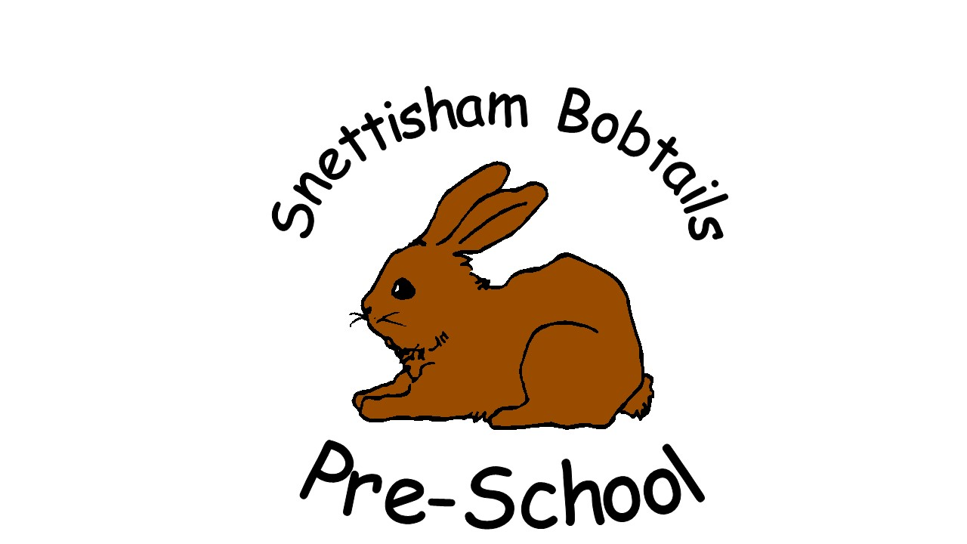
Application to join

Snettisham Bobtails Pre-School
Snettisham Primary School, School Rd, Snettisham. Norfolk. PE31 7LT
Setting: 07855078038 Admin: 01485 541274
Charity No: 1029400 OFSTED URN: 545971

Personal details
First name(s) of child:
Surname of child: |  |  |  |  |  |  |  |  |  |  |  |  |  |  |  |  | Date of birth:
Full address:
 |  |  |  |  |  |  |  |  |  |  |  |  |  |  |  |  | Postcode:
Parent/carer name (1):
Relationship to child:
Full address (if different):
 |  |  |  |  |  |  |  |  |  |  |  |  |  |  |  |  | Postcode:
Daytime/work tel: |  |  |  |  |  |  |  |  |  |  |  | Home: |  |  |  |  |  |  | Mobile:
Parent/carer name (2):
Relationship to child:
Full address (if different):
 |  |  |  |  |  |  |  |  |  |  |  |  |  |  |  |  | Postcode:
Daytime/work tel: |  |  |  |  |  |  |  |  |  |  |  | Home: |  |  |  |  |  |  | Mobile:
Session request
Preferred start date:
Please tick the sessions you would like your child to attend:

Morning session |  |  |  |  |  |  |  |  |  | □ Monday |  |  | □ Tuesday |  |  | □ Wednesday |  |  |  |  |  | □ Thursday |  |  |  |  | □ Friday
Afternoon session |  |  |  |  |  |  |  |  |  | Monday |  |  | Tuesday |  |  | Wednesday |  |  |  |  |  | Thursday
This application places your child on our waiting list. We will contact you as soon as a suitable place becomes available. Please note that completion of this form does not guarantee a place for your child.
Once your child is offered a place and you accept it, on admission further personal information and family details are required for our records
If you find that you no longer need the place, please inform us as soon as possible.
Signed parent/carer (1): |  |  |  |  |  |  |  |  |  |  |  |  |  |  |  |  |  |  |  | Date:
Signed parent/carer (2): |  |  |  |  |  |  |  |  |  |  |  |  |  |  |  |  |  |  |  | Date:
Please be advised that this application form and offer of a place is subject to our terms and conditions provided to you. By signing this document, you acknowledge that you have read, understood and agree to these terms and conditions.
For office use only:
Tear off the following part to return to the parent(s)
A place will be available for |  |  |  |  |  |  |  |  |  |  |  |  |  |  |  |  |  |  |  |  |  |  |  |  |  | (child’s name)
* on |  |  |  |  |  |  |  |  |  |  |  | (date) |  | * or; we will notify you when a place becomes free.
Signed on behalf of the provider:
Name: |  |  |  |  |  |  |  |  |  |  |  |  |  |  | Job title: |  |  | Administrator

*Please delete whichever is not applicable.

